

THE COMPOSITE BUDGET
of the
ADA WEST DISTRICT ASSEMBLY
for the

2026 FISCAL YEAR

OCTOBER, 2025
APPROVAL STATEMENT
Ada West District Assembly at its General Assembly Meeting Held on ………. approved the District Composite Budget for the 2026 Fiscal Year.

............................. ………………………….
PRESIDING MEMBER DISTRICT COOR. DIRECTOR
(HON. LAWRENCE K. NGUNEKPEKU) (GORDON WALTER DOE)

Table of Contents

List of Tables 4
List of Figures Error! Bookmark not defined.
INTRODUCTION 5
1.0 STRATEGIC OVERVIEW OF THE ASSEMBLY 5
1.1 Name of District and LI Establishing It 5
1.2 Population Structure 5
1.3 Vision 5
1.4 Mission 5
1.5 Core Function of the Assembly 5
1.6.1 Education 6
1.6.2 Health 6
1.6.3 Tourism 8
1.6.4 Water and Sanitation 8
1.6.5 Road Network 9
1.6.6 Market Centre 9
1.6.7 Agriculture 9
1.7 IDENTIFIED KEY DEVELOPMENT ISSUES/CHALLENGES 9
1.8 ADA WEST DISTRICT ADOPTED POLICY OBJECTIVES 6
1.9 KEY ACHIEVEMENTS FOR 2024 18
2.0 OUTLOOK FOR 2025-2028 Error! Bookmark not defined.
2.1 REVENUE MOBILIZATION STRATEGIES FOR KEY REVENUE SOURCES IN 2025 33
3.0 CONCLUSION 58

List of Tables

tables 1: Financial Performance- Revenue 10
Tables 2: Revenue Performance-All Revenue Sources 11
Tables 3: Financial Performance-Expenditure-Igf Only Error! Bookmark not defined.
Tables 4: Financial Performance-Expenditure 13
Tables 5: 2024 Budget Programme Performance 14
Tables 6: Number Of Farm Inputs Had Been Distributed To Farmers In The District. Error! Bookmark not defined.
Tables 7: 2024 Key Projects And Programmes From All Sources 22
Tables 8: Policy Outcome Indicators And Targets 23
Tables 9: Sanitation Budget Performance- 2024 24
Tables 10: Development Partner Supported Programmmes (Eg. Child Right, Protection And Promotion, And Safety Net Etc 26
Tables 11: Government Flagship Projects/ Programmes Error! Bookmark not defined.
Tables 12: Mmda Adoted Policy Objectives For 2024 Linked To Sustainable Development Goals (SDGS) 28
Tables 13: Policy Outcome Indicators And Targets 30
Tables 14: 2025-2028 Revenue Projections- IGF Only 32
Tables 15: 2025-2028 Revenue Projections-All Revenue Sources 36
Tables 16: Expenditure By Budget Programme And Economic Classification –All Funding Sources 37
Tables 17: Government Flagship Projects/ Programmes Error! Bookmark not defined.
Tables 18: The Underlisted Companies Are As Follows: Error! Bookmark not defined.
Tables 19: Expenditure Projections –All Funding Sources Error! Bookmark not defined.
Tables 20: Projects For 2025 and Corresponding Cost And Justification 40
Tables 21: Projects For 2025 and Corresponding Cost And Justification Error! Bookmark not defined.
Tables 22: Sanitation Budget 54
Tables 23: Development Partner (DP) Supported Programmmes (Eg. Right,Protection And Promotion, And Safety Net Etc 56

INTRODUCTION

STRATEGIC OVERVIEW OF THE ASSEMBLY

1.1 Name of District and LI Establishing It
The Ada West District is one of the Twenty-Nine (29) Assemblies in the Greater Accra Region. It is situated in the south-eastern corner of Ghana. It was carved out of the former Dangme East in the year 2012 by the Legislative Instrument 2129. The district lies between Latitudes 5°45’S and 6°00’N and Longitude 0°20’W and 0°35’E. The total land area of the district is approximately 323.72 square km, which represents almost 10% of the total land size of the Greater Accra Region

1.2 Population Structure
According to the 2021 Population and Housing Census, the Ada West District has a total population of 76,087. The 2026 projected population is 83,419, Females at 42,708 representing 51.19 percent and Males at 40,710 representing 48.80 per cent of the district population at a growth rate of 2.3%.

1.3 Vision
To become the most attractive, responsive and resilient District Assembly in Ghana

1.4 Mission
The Ada West District Assembly exists “to improve the living standard of its citizenry through co-ordination with all stakeholders to mobilize appropriate resources for the implementation of relevant socio-economic interventions in a sustainable manner.

1.5 Core Function of the Assembly
The core functions of the Ada West District Assembly are outlined below:
- Responsible for the overall development of the district.
- To exercise political and administrative authority in the district, provide guidance, give direction to and supervise all other administrative authorities in the district.
- Maintain security and public safety.
- Exercise deliberative, legislative and executive functions.
- Formulate and execute plans, programs and strategies for the effective mobilization of the resources necessary for the overall development of the district.
- Promote and support productive activity and social development in the district and remove any obstacles to initiate development.
- Initiate programs for the development of basic infrastructure and provide district works and services.
- Be responsible for the development, improvement and management of human settlements and the environment in the district.
- Guide, encourage and support sub-district local government bodies, public agencies and local communities to perform their roles in the execution of approved developmental plans.

1.6 ADA WEST DISTRICT ADOPTED POLICY OBJECTIVES
1. Broaden & strengthen participation of District Councils and Institutions of global governance
2. Ensure Free, Equitable and Quality Education for all by 2030
3. Achieve universal coverage, inclusive and access to equal health care service
4. Achieve access to adequate and equitable sanitation and hygiene
5. Ensure access to adequate, safe, and affordable housing and basic service
6. Build and upgrade education facilities that are disability friendly.
7. End Hunger and Access to Sufficient Food to all people in vulnerable situation
8. Eliminate violence against women and children
9. Strengthen resilient and adaptive capacity to climate related hazards &national disaster
10. Ensure Full and Efficient Participation to Women
12. To facilitate and sustain resilient infrastructure in developing cities
13. Improve human capacity development.

1.7. DISTRICT ECONOMY

1.7.1 Education
The Ada West District has a total of 611 teachers supporting teaching and learning activities. Out of this number, 611 teachers, representing 100%, constitutes the total number of trained teachers in the entire district (with 445 being females and 489 constituting males) while 323 are untrained, representing 34.5 %, who are currently assisting the trained teachers. Table 1.8 below presents the total number of teachers per Circuits in the District.
Table 1.1: Number of teachers
Level | Academic Years
Level | 2021/2022 |  |  | 2022/2023 |  |  | 2023/2024
Level | Public | Private | Total | Public | Private | Total | Public | Private | Total
KG | 67 | 69 | 136 | 67 | 50 | 117 | 67 | 70 | 137
PRIM | 287 | 132 | 419 | 287 | 143 | 430 | 266 | 146 | 412
JHS | 260 | 85 | 345 | 260 | 88 | 348 | 278 | 107 | 385
TOTAL | 614 | 286 | 900 | 614 | 281 | 895 | 611 | 323 | 934
Source: Ghana Education Service, Sege, 2025
The number of teachers in the public schools at all levels had witnessed a considerable decrease from 2022/2023 to 2023/2024 though it was the same in the immediate past academic year. At the KG level, the total number of teachers was maintained at 64, while at the primary and JHS levels, the teachers’ population reduced from 287 to 266 and increased from 260 to 270 respectively. Aside the above, having the tendency to increase pupil-teacher ratio, it also has the probability of contributing to poor performance of students as there is a probability of teachers not being able to adequately attend to the academic needs of every student. There was, however, a decrease in the number of trained teachers in the public schools from 614 in 2022/2023 to 611 in 2023/2024 in trained teachers as indicated in the table below.
Table 1.2: Number of trained/untrained teachers in the public schools
LEVEL | Academic Years
LEVEL | 2021/2022 |  |  |  |  | 2022/2023 |  |  |  |  | 2023/2024
LEVEL | M | F | Trained | Untrained | Total | M | F | Trained | Untrained | Total | M | F | Trained | Un trained | Total
KG | 18 | 67 | 67 | 69 | 136 | 15 | 102 | 67 | 50 | 117 | 29 | 108 | 67 | 70 | 137
PRIM | 228 | 217 | 287 | 141 | 428 | 367 | 196 | 287 | 143 | 430 | 192 | 220 | 266 | 146 | 412
JHS | 267 | 80 | 260 | 85 | 345 | 255 | 93 | 260 | 88 | 348 | 268 | 117 | 278 | 107 | 385
TOTAL | 513 | 364 | 614 | 295 | 909 | 637 | 391 | 614 | 281 | 895 | 489 | 445 | 611 | 323 | 934
Source: Ghana Education Service, Sege, 2025

1.7.2 Health
The District currently has two types of health facilities namely polyclinic and health centres/post. The district has nine (9) Health Facilities, one (1) Polyclinic, three (3) Health Centres and five (5) Operational CHPs Compounds,

1.7.3 Tourism
Tourism is an activity which is not yet developed in the district. Ada west also has a few guest houses contributing to the hospitality industry which complement the development of the tourism industry. The District can boast of a number of tourist sites. Some of these sites are:
a. Okorhuem- Ancestral home of Adas.

b. Songor Ramsar site- 75 species of birds.

c. Nkyinkyin Installation Projects – Nuhale - Artifacts and Sculptures

d. Monkey Sanctuary – Sege Amatekoni

e. Umbrella Shade Rock – Kpetuhuor - Beautiful landscape which showcases a rich blend of lush with stark, steep and rocky slopes

1.7.4 Water and Sanitation
The Ghana Statistical Service in the 2021 PHC recorded a total of 18,294 households in the Ada West District. Out of which almost all households identified (18,277) have access to various sources of water for drinking. These sources are categorized into either Improved or Unimproved water sources. Some of the Improved water sources that benefit the District include Public standpipe, Borehole, Pipe-borne inside and outside dwelling, Sachet water, protected well, bottled water and rainwater.

1.6.5 Road Network
The total road surface in the District is about 289.05km made up of about 99.49km tarred representing 34.42% tarred and about 192.45 untarred representing 66.58%.

1.6.6 Market Centre
The District has one major market located in Sege, where all the economic activities especially trading thrive the most. There are two market days which are Mondays and Thursdays every week.

1.6.7 Agriculture
The Ada West District is noted for the cultivation of cassava, maize, legumes, fruits and varieties of vegetables. With the exception of maize and cassava, the district accounts for more than 50% of the regional output for these crops. Livestock rearing is another important agricultural activity in the district. The livestock identified in the district are cattle, sheep and goats, pig, poultry (fowls, turkey, duck, and guinea fowl.).
The district is noted for marine fishing activities. The major fishes harvested are King Fish, Anchovies, Mackerel, Tuna, Shrimp, Herrings and Barracuda.

1.7 IDENTIFIED KEY DEVELOPMENT ISSUES/CHALLENGES
- Inadequate Educational infrastructure
- Boundary Disputes with sister Districts
- Inadequate market infrastructure
- Poor quality and inadequate road transport networks
- Inadequate Health Facilities
- Inadequate data for revenue mobilization
- Poor sanitation and waste management
- Inadequate residential accommodation for staff and security personnel.

 | REVENUE PERFORMANCE – INTERNALLY GENERATED FUND (IGF 2023-2025)
ITEM | 2023 |  | 2024 |  | 2025 |  | % performance as at September  Actual  Budget | % Performance as at September, 2025
ITEM | Budget  (GH¢) | Actual  (GH¢) | Budget  (GH¢) | Actual  (GH¢) | Budget  (GH¢) | Actual as at September ,2025  (GH¢) | % performance as at September  Actual  Budget | Item.  Subtotal
Property Rates | 53,756.00 | 75,079.00 | 234,400.00 | 272,142.19 | 500,000.00 | 384,412.00 | 76.88 | 14.20
Basic Rates | 1,000.00 | 10.00 | 2,000.00 | 1,000.00 | 2,000.00 | 2,040.00 | 102.00 | 0.08
Special Rates | - | - | 3,000.00 | 0.00 | 5,000.00 | 20.00 | 0.4 | 0.00
Fees | 667,100.64 | 595,955.00 | 919,380.00 | 769,279.00 | 1,755,022.00 | 1,320,127.00 | 75.22 | 48.78
Fines | 14,000.00 | 21,650.00 | 15,400.00 | 19,200.00 | 39,000.00 | 9,800.00 | 25.13 | 0.36
Licenses | 595,500.00 | 446,734.71 | 577,222.30 | 422,494.00 | 318,978.00 | 347,329.00 | 108.89 | 12.83
Land | 390,838.98 | 402,546.77 | 603,597.70 | 843,940.54 | 780,000.00 | 558,486.50 | 71.60 | 20.64
Rent | 65,500.00 | 41,862.00 | 45,000.00 | 79,890.00 | 100,000.00 | 84,050.00 | 84.05 | 3.11
Investment | 0.00 | 0.00 | 0.00 | 0.00 | 0.00 | 0.00 | 0.00
Total | 1,787,695.62 | 1,630,122.68 | 2,400,000.00 | 2,407,945.73 | 3,500,000.00 | 2,706,264.50 | 77.32
Tables 1.3: FINANCIAL PERFORMANCE- REVENUE

Tables 1.4: REVENUE PERFORMANCE-ALL REVENUE SOURCES
Item | 2023 |  | 2024 |  | 2025 |  | % Perf. as at September. 2025 | % Per. as at September,2024
Item | Budget (GH¢) | Actual (GH¢) | Budget (GH¢) | Actual (GH¢) | Budget (GH¢) | Actual as of September 2025 (GH¢) | % Perf. as at September. 2025 | Actual/Budget 100
IGF | 1,787,695.62 | 1,630,122.68 | 2,400,000.00 | 2,407,945.73 | 3,500,000.00 | 2,706,264.50 | 77.32 | 7.23
Compensation transfer | 3,976,037.20 | 3,982,199.66 | 4,315,504.00 | 4,660,224.86 | 6,000.000.00 | 4,621,211.57 | 77.08 | 13.56
Goods & Services-Decentralized | 132,530.00 | 0.00 | 139,496.89 | 0.00 | 101,500.00 | 0.00 | 0.00 | 0.00
Assets Transfer | - | - | - | - | - | - | - | -
DACF-Assembly | 2,552,819.90 | 825,153.93 | 3,708,802.08 | 1,216,860.64 | 20,231,016.51 | 6,621,211.57 | 32.72 | 19.44
DACF-RFG-Investment | 1,132,419.00 | 425,000.00 | 1,772,891.00 | 1,725,454.00 | 3,108,662.00 | 0.00 | 0.00 | 0.00
DACF-RFG- Capacity Building | 45,859.00 | 0.00 | 41,571.00 | 41,571.00 | 83,142.00 | 0.00 | 0.00 | 0.00
DACF-MP | 700,000.00 | 379,657.72 | 1,148,458.00 | 95,704.83 | 2,800,000.00 | 810,723.58 | 28.95 | 2.38
Secondary Cities | - | - | - | - | - | - | - | -
Other Transfers:
Disability Fund | 130,787.62 | 183,085.17 | 300,000.00 | 266,773.16 | 400,000.00 | 359,287.87 | 89.82 | 1.05
HIV/ (MSHAP) | 21,797.93 | 8,691.32 | 25,000.00 | 6,518.49 | 101,155.05 | 31,148.57 | 30.79 | 0.09
Modernised Agric. Ghana (MAG) | 32,294.33 | 32,294.33 | 0.00 | 0.00 | 0.00 | 0.00 | 0.00 | 0.00
UNICEF (Integrated Social Service) | 30,000.00 | 30,000.00 | 30,000.00 | 30,000.00 | 35,000.00 | 0.00 | 0.00 | 0.00
DRIP | - | - | 500,000.00 | 500,000.00 | 0.00 |  | - | -
Hon. Assembly Members Allowance | - | - | - |  | 228,000.00 | 57,200.00 | 25.08 | 0.17
Grand Total | 10,542,240.60 | 7,496,204.81 | 14,381,722.97 | 10,951,052.71 | 36,588,475.56 | 15,207,047.66 | 44.64 | -

Tables 1.5: FINANCIAL PERFORMANCE-EXPENDITURE
EXPENDITURE | EXPENDITURE PERFORMANCE (ALL DEPARTMENTS) ALL FUNDING SOURCES
EXPENDITURE | 2023 |  | 2024 |  | 2025
EXPENDITURE | Budget (GH¢) | Actual (GH¢) | Budget  (GH¢) | Actual (GH¢) | Budget (GH¢) | Actual as September 2025 (GH¢) | % Performance
Compensation | 3,976,037.20 | 3,982,199.00 | 5,657,760.34 | 5,982,199.00 | 6,000,000.00 | 4,621,211.57 | 77.02
Goods and Services | 3,637,220.60 | 2,542,127.63 | 5,722,416.27 | 3,542,127.63 | 17,722,416.27 | 3,196,842.00 | 16.66
Assets | 2,929,182.20 | 1,413,615.93 | 3,001,546.36 | 1,426,725.08 | 10,346,059.29 | 74.031.00 | 0.72
Total | 10,542,440.60 | 7,496,204.81 | 14,381,722.97 | 10,951,051.71 | 34,068,475.56 | 7,892,084.57 | 22.45

Tables 1.6: EXPENDITURE BY BUDGET PROGRAMME AND ECONOMIC CLASSIFICATION- All Funding Sources 2025 BUDGET PROGRAMME PERFORMANCE AS AT SEPTEMBER,2025
BUDGET PROGRAMME
BUDGET PROGRAMME | BUDGET (GH¢) | COMPENSATION OF EMPLOYEES (GH¢) | GOODS AND SERVICES (GH¢) | CAPITAL EXPENDITURE (GH¢) | TOTAL (GH¢)
Management and Administration | 5,046,840.06 | 3,366,338.00 | 1,880,889.35 | 0.00 | 5,247,227.35
Infrastructure Delivery and Management | 13,550,080.37 | 254,452.21 | 452,694.21 | 74,031.00 | 771,057.21
Social Service Delivery | 8,452,352.21 | 415,221.89 | 577,253.55 | 0.00 | 992,475.44
Economic Development | 562,782.39 | 251,142.00 | 154,124.00 | 0.00 | 405,266.00
Environment and Sanitation Management | 6,456,163.53 | 334,057.47 | 142,001.00 | 0.00 | 476,058.57
GRAND TOTAL | 34,068,475.56 | 4,621,211.57 | 2,952,510.00 | 74,031.00 | 7,892,084.57

Tables 1.7: 2025 KEY PROJECTS AND PROGRAMMES FROM ALL SOURCES
NO | NAME OF PROJECT | SOURCE OF FUND | AMOUNT BUDGETED  (GH¢) | ACTUAL PAYMENT AS AT September 2025 (GH¢) | OUTSTANDING  (GH¢)
 | Management and Administration
1 | Construction of 1No 2 Bedroom Semi-detached Staff Bungalow at Sege | DACF | 565,304.80 | 120.530.61 | 444,774.19
2 | Construction of DCDs Bungalow at Sege-Staff Village | DACF | 460,163.33 | 124,858.17 | 335,305.16
3 | Construction of DCEs Bungalow at Sege-Staff Village | DACF | 862,031.61 | 98,977.50 | 852,132.11
 | Social Service Delivery
4 | Construction of 4-Unit Storey, One bed apartment nurse’s quarter at Sege | DACF-RFG | 450,543.45 | 412,008.93 | 38,534.52
5 | Construction of 1No. CHPs Compound at Lolonya- Abuanorkope | DACF-RFG | 499,804.38 | 359,673.80 | 140,130.58
6 | Construction of 1No 3 classroom block at Sorkope | DACF-RFG | 442,200.00 | 420,489.40 | 21,710.60
 | Construction of 4Seater WC Toilet for Luhour CHPs Compound | DACF-RFG | 198,600.00 | 188,670.00 | 9,930.00
 | Construction of 4-Seater water closet with male and female urinal for Health Centre at Bornikope | DACF-RFG | 198,710.00 | 188,775.00 | 9,935.00
 | Construction of 1.2 triple cell and culvert and filling to the approaches at 3.6km on Koluedo to Madavonu road | DACF-RFG | 299,871.02 | 284,877.47 | 14,993.55
 | Renovation of 6 Units Classroom Block at Caesarkope | DACF-RFG | 190,142.00 | 180,634.90 | 9,507.10
 | GRAND TOTAL |  | 4,167,370.59 | 2,258,965.17 | 1,938,405.42

NON-FINANCIAL PERFORMANCE BY PROGRAMMES

1.9 KEY ACHIEVEMENTS FOR 2025
The Ada West Assembly is mandated by the Local Governance Act, 2016 (Act 936) to plan and implement programmes and projects that will ensure the improvement of living standard of the people and propel socio –economic growth in the District. In line with its core mandate, the District has achieved an enviable record of success summarised below:
Figure 1: Construction of 4No 4 Semi-detached Bungalow for Nurses in Sege

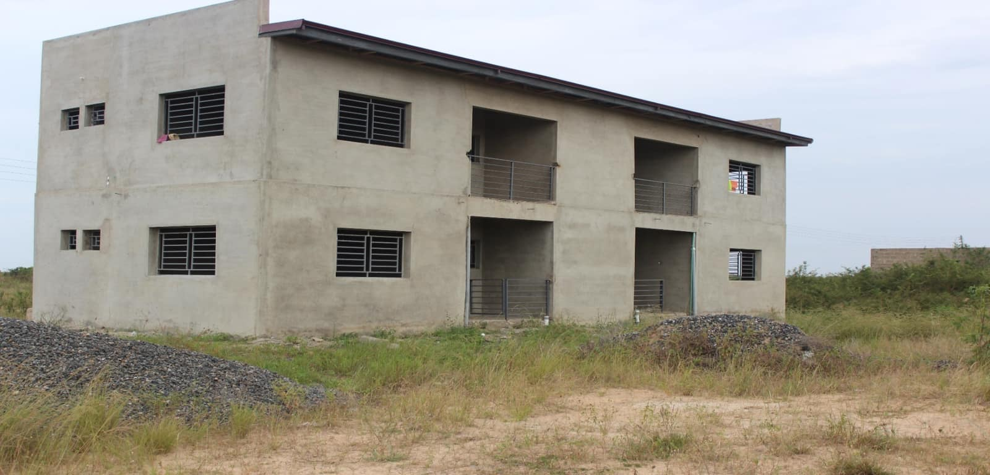
Source of Fund: DACF-RFG

Figure 2: Construction of staff bungalow for the DCE
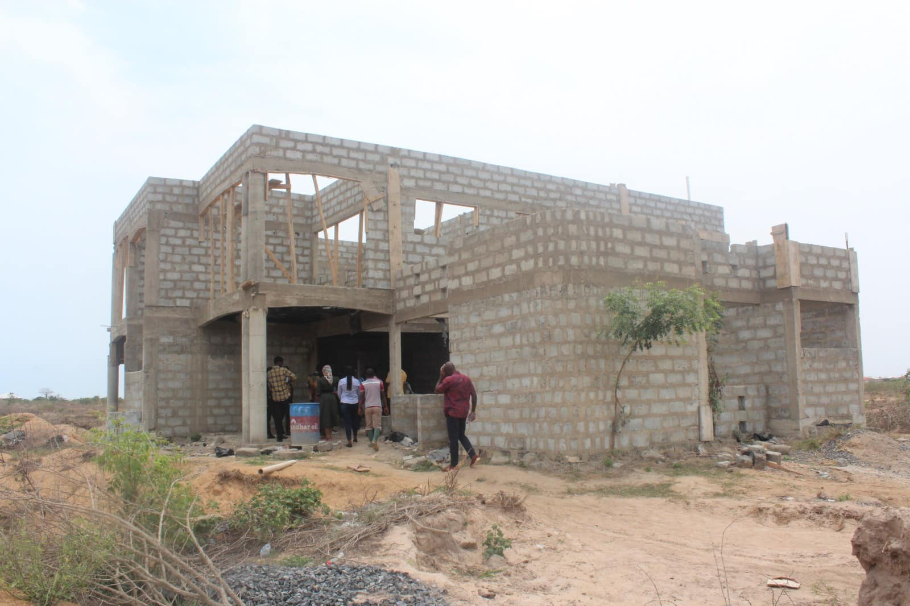
SOURCE OF FUND: DACF

Figure 1: Construction of CHPs Compound at Lolonaya
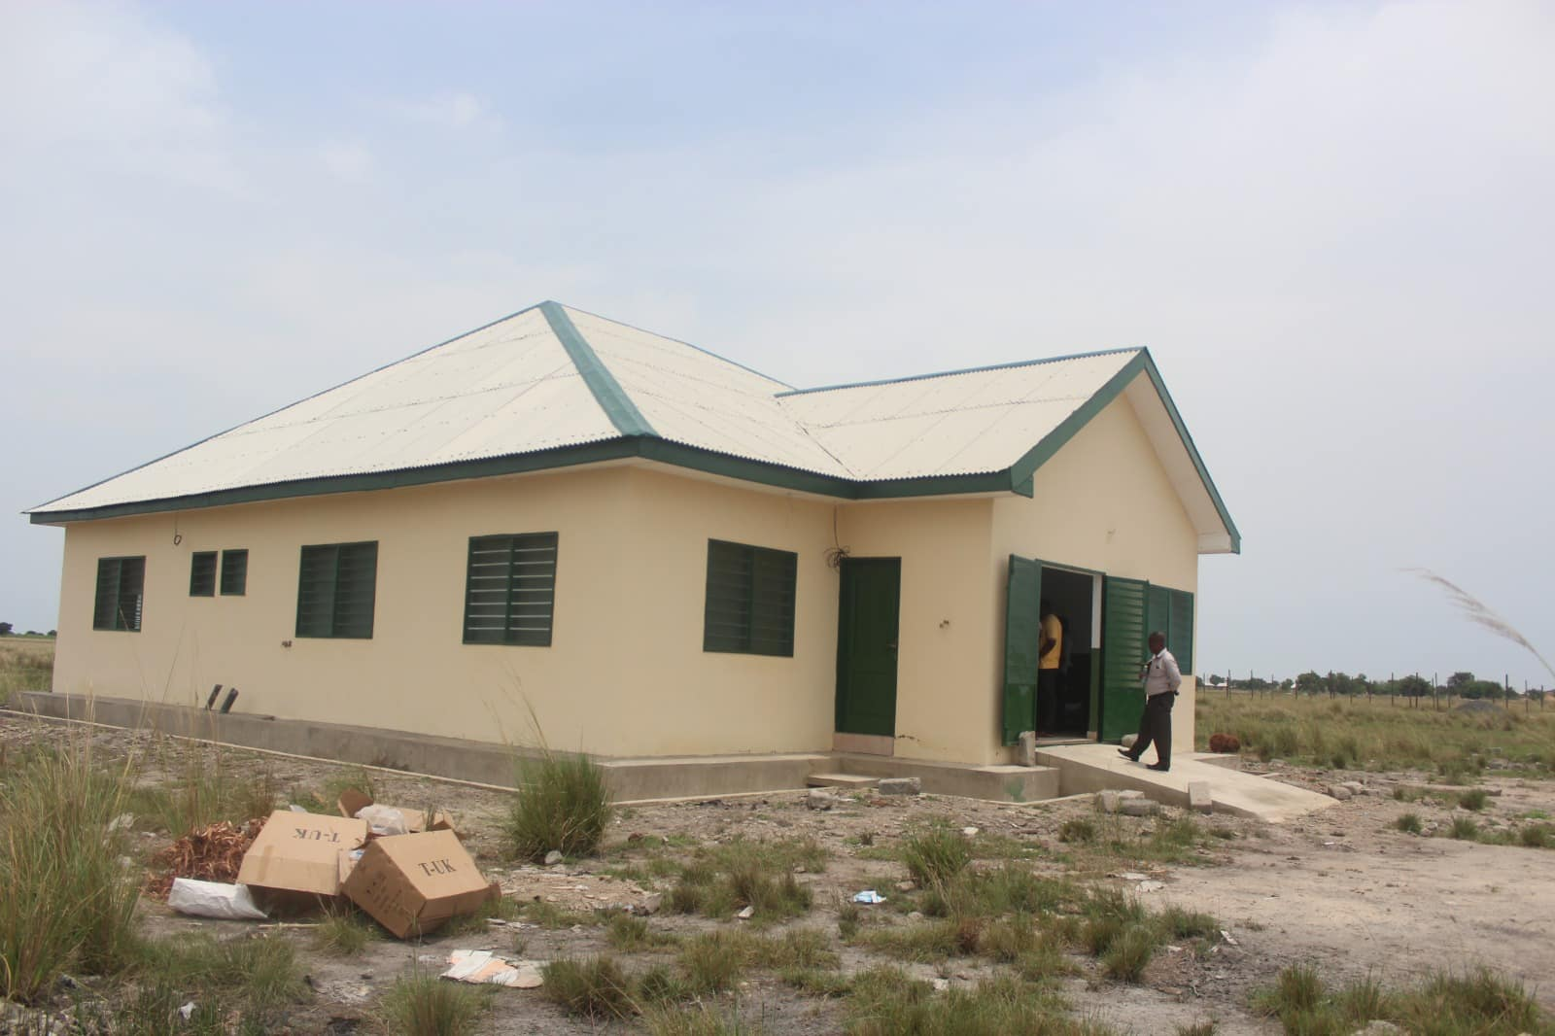
Source of Fund: DACF-RFG
Figure 2: Construction of Semi-detached staff bungalow at Sege Staff Village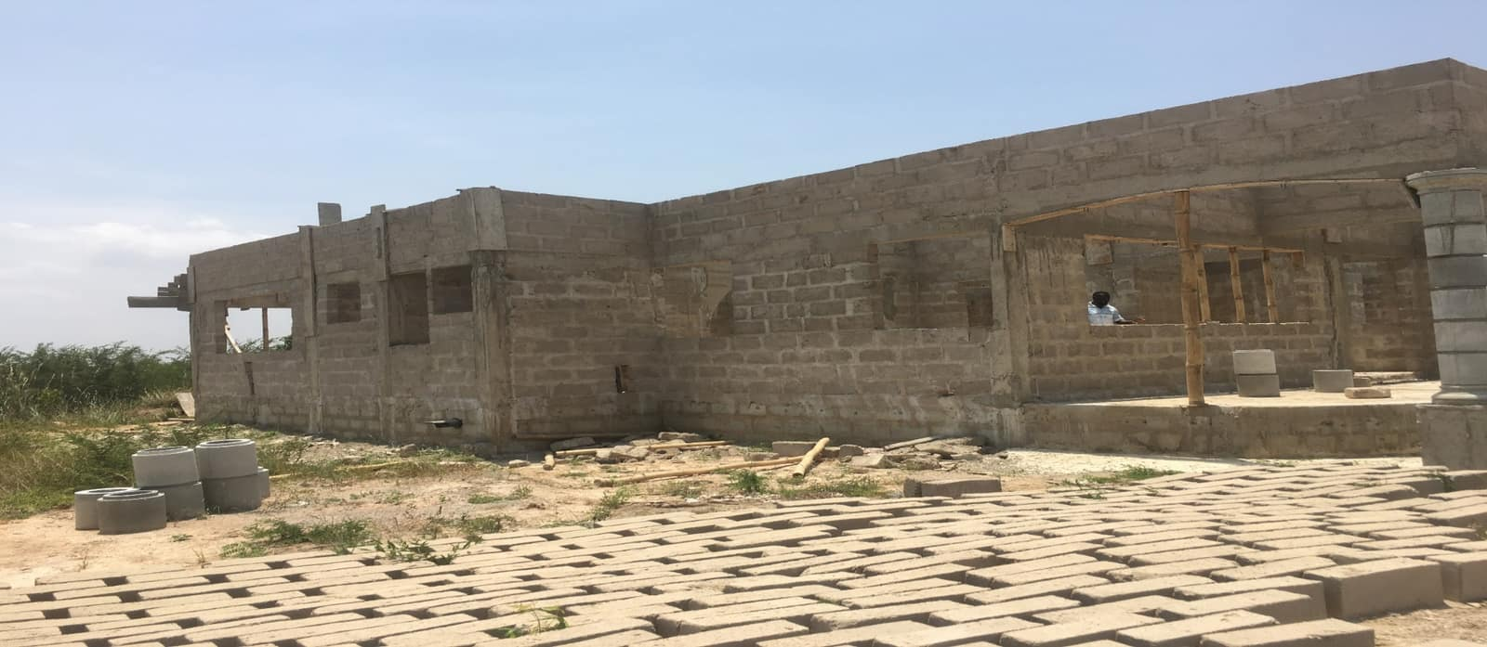
Source of Fund: DACF

Figure 5: Renovation of District Assembly hall

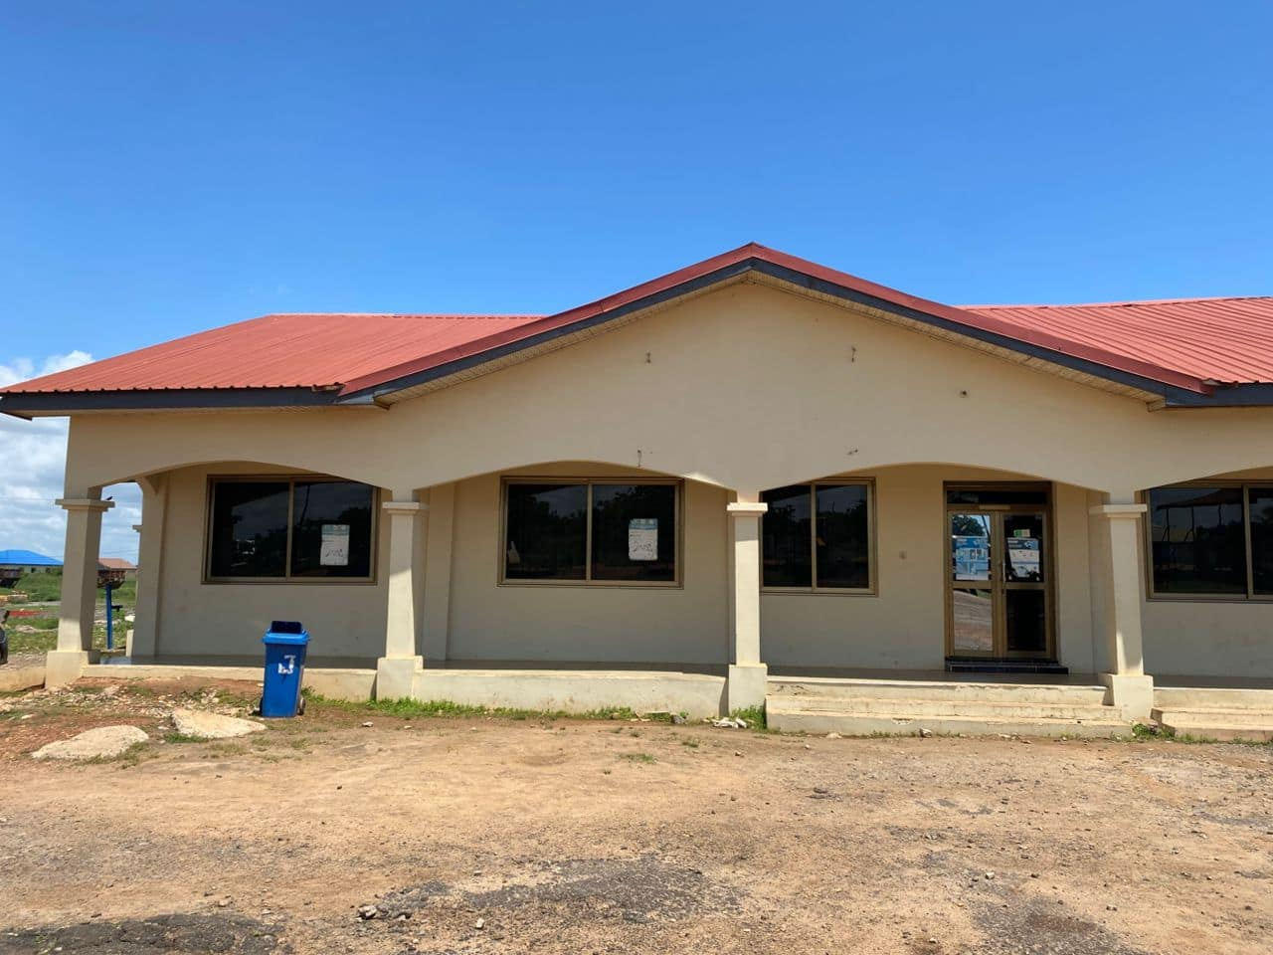
Source of Fund: IGF

- Ensured proper maintenance of Peace & Security (Chieftaincy Resolution & Police Visibility).
- Purchased of chop box and mattress of 170 pieces each for students going to SHS this year.

Tables 1.8: POLICY OUTCOME INDICATORS AND TARGETS
OUTCOME INDICATOR | UNIT OF MEASUREMENT | Previous Year’s Performance (2024) |  | Current Year’s Actual Performance (2025)
 |  | Target | Actual | Target | Actual as at September, 2025
Improve Financial Management | Value of IGF increased | 2,400,000.00 | 2,407,945.73 | 3,500,000.00 | 2,706,264.50
Improve Financial Management | Number of Commission collectors recruited and deployed | 10 | 2 | 5 | 1
Improve Financial Management | Efficient collection monitored | 4 | 4 | 4 | 2
Increase inclusive and equitable access to education  Improved access to Health Care | Number of Classroom Built | 3 | 1 | 3 | 0
 | Number of furniture supplied | 1,000 | 1,000 | 3,000 | 0.
 | Number of Brilliant but needy students supported | 25 | 10 | 30 | 0
 | Number of mock exams organised | 1 | 1 | 2 | 0
 | Number of Health Facilities Built | 2 | 1 | 2 | 0
Social Protection towards the poor and vulnerable effectively promoted | Number of registered households under (LEAP) paid | 500 | 432 | 600 | 453
Improved settlement planning and development control | Number of spatial planning committee meetings organized | 12 | 10 | 12 | 7
Improved settlement planning and development control | Number of Technical Planning Committee meeting organized | 12 | 10 | 12 | 7
Improved settlement planning and development control | Number of Field quarterly report | 4 | 2 | 4 | 0
Improved settlement planning and development control | Number of communities with planning schemes | 7 | 0 | 4 | 0

Tables 1.9: SANITATION BUDGET PERFORMANCE- 2025
NO | NAME OF ACTIVITY/PROJECT | BUDGET(GH¢) | Actual Payment As At September, 2025 (GH¢)
a SOLID WASTE
1 | Sanitation Management | 60,000.00 | 30,020.00
2 | Construction of Urinals at Sege Market and the Lorry Station | 40,000.00 | 0.00
3 | Evacuation of refuse dump and maintenance of final dumping site | 250,000.00 | 0.00
4 | Organisation of National Sanitation Day | 50,000.00 | 0.00
5 | Management of sanitation in the principal streets of the district | 150,000.00 | 0.00
6 | Procurement of 4 No. refuse containers | 150,000.00 | 0.00
7 | Regular dislodging of all institution and public toilets | 57,860.98 | 7.052.00
8 | Fumigation District: 91,568.75* 4 quarters) | 366,275.00 | 91,568.74
9 | Sanitation Improvement Package (SIP) District : 96,801.25* 4 quarters | 387,205.00 | 96,801.25
10 | Monitoring and Supervision of environmental Service Providers | 65,000.00 | 0.00
11 | Conduct sensitization on WASH activities | 45,000.00 | 0.00
12 | Procurement of Sanitary Tools and Equipment | 185,000.00 | 0.00
13 | Support implementation of Community Led Total Sanitation | 50,000.00 | 0.00
14 | Purchase of land for refuse dump site at Sege | 100,000.00 | 0.00
 | Sub-Total | 1,956,340.98 | 218,389.99
b LIQUID WASTE
1 | Completion of 10-seater water closet toilet with shower facilities at Akplagbanya | 260,000.00 | 0.00
2 | Completion of 10-seater water closet toilet with shower facilities at Sege | 260,000.00 | 0.00
3 | Completion of 10 seater water closet toilet with shower facilities at Anyamam | 260,000.00 | 0.00
4 | Completion of 10 seater water closet toilet with shower facilities at Agbedrafor | 260,000.00 | 0.00
5 | Completion of 10 seater water closet toilet with shower facilities at Caesarkope | 260,000.00 | 0.00
6 | Completion of 10 seater water closet toilet with shower facilities at Loyonya | 260,000.00 | 0.00
7 | Renovation of Public Toilet at Sege Lorry Station | 250,000.00 | 0.00
8 | Renovation of Public Toilet at Koluedo | 300,000.00 | 0.00
 | Sub-Total | 2,110,000.00 | 0.00
 | Grand Total | 4,066,340.98 | 218,398.99

Tables 1.10: DEVELOPMENT PARTNER SUPPORTED PROGRAMMMES (eg CHILD RIGHT, PROTECTION AND PROMOTION, AND SAFETY NET ETC
Child Right and Protection
No | Name of Activity/ Project | Budget | Actual as at September 2025
1 | Community Entry, sensitization, monitoring and assessment on child online safety | 7,000.00 | 6,989.96
2 | Education on child neglect and child labour in Ten (10) communities | 10,000.00 | 8,254.00
3 | Community mobilisation and sensitization on teenage pregnancy and parental care in ten (10) communities | 9,000.00 | 7,584.30
4 | Training of community focal persons on child protection issues | 9,000.00 | 8,562.32
 | Total | 35,000.00 | 31,390.58

0OUTLOOK FOR 2026

Tables 1.10: ADA WEST ADOTED POLICY OBJECTIVES FOR 2026
FOCUS AREA | POLICY OBJECTIVES | BUDGET  ALLOCATION
Strong and Resilient Economy | 1.Ensure Improved Fiscal Performance and Sustainability | 6,952,023.10
Education and Training | 2.Enhance inclusive and equitable access to, and participation in quality education at all levels | 6,562,562.00
Health and Health services | 1.Ensure affordable, equitable and easily accessible health care services | 5,789,521.02
Social Protection | 1.Strengthen Social Protection, especially for children, women, persons with disability and the elderly  2.Promote participation of PWDs in politics, electoral democracy and governance | 4,955,717.58
Water and Environmental Sanitation | 1.Increase access to sanitation  2.Prevent environment pollution  3.Improve access to safe and reliable water supply services for all, | 4,066,340.98
Disaster Management | 13.Promote proactive planning for disaster prevention and mitigation | 40,000.00
Agricultural and Rural Development | 14.Ensure improved public investment  15.Promote demand –driven approach to agricultural development | 852,251.00
FOCUS AREA | POLICY OBJECTIVES | BUDGET  ALLOCATION
Spatial/ Land Use Planning | 16.Promote sustainable spatially integrated balanced and orderly development of human settlement | 258,040.84
Local Government and Decentralisation | 7. Strengthen Fiscal Decentralisation | 4,438,918.00
GRAND TOTAL |  | 33,915,374.52

Tables 1.12: POLICY OUTCOME INDICATORS AND TARGETS
OUTCOME INDICATOR | UNIT OF MEASUREMENT | Baseline (2024) |  | Current Year (2025) |  | Year (2026 Indicative) | Indicative Year (2027) | Inductive (2028) | Indicative (2029)
 |  | Target | Actual | Target | Actual as at September | Target | Target | Target | Target
Improve Financial Management | Value of IGF increased | 2,400,000.00 | 2,407,945.73 | 3,500,000.00 | 2,706,264.50 | 3,850,000.00 | 4,235,000.00 | 4,658,500.00 | 4,791,600.00
Improve Financial Management | Number of Commission collectors recruited and deployed | 15 | 11 | 30 | 20 | 35 | 40 | 45 | 50
Improve Financial Management | Efficient collection monitored | 4 | 2 | 4 | 1 | 4 | 4 | 4 | 4
Improve Financial Management | Operationalization of Sub-office and Area Councils | 3 | 3 | 3 | 3 | 3 | 3 | 3 | 3
Increase inclusive and equitable access to education | Number of Classroom Built | 3 | 1 | 3 | 0 | 3 | 3 | 4 | 4
Increase inclusive and equitable access to education | Number of furniture supplied | 450 | 400 | 400 | 0 | 700 | 600 | 600 | 400
Increase inclusive and equitable access to education | Number of Brilliant but needy students supported | 25 | 10 | 10 | 0 | 25 | 30 | 35 | 40
Improved access to Health Care | Number of Health Facilities Built | 2 | 2 | 2 | 0 | 3 | 4 | 4 | 4
Improve Environmental Sanitation | Number of Disposal site evacuated | 3 | 0 | 5 | 5 | 2 | 2 | 1 | 1
Improved state of Feeder Roads | Kilometres of roads reshaped | 30km | 10kms | 40km | 7km | 40km | 30km | 40km | 50km
OUTCOME INDICATOR | UNIT OF MEASUREMENT | Baseline (2024) |  | Current Year (2025) |  | Inductive (2026) | Indicative (2027) | Inductive (2028) | Inductive (2029)
 |  | Target | Actual | Target | Actual | Target | Target | Target | Target
Improved the capacity of staff on Local Government Act and Local Government Protocol | Number of staff trained | 28 | 28 | 20 | 15 | 40 | 40 | 40 | 50
Conduct Disease surveillance | Number of animals surveyed | 230 | 234 | 80 | 70 | 100 | 100 | 100 | 100
Developed the Capacity of Farmers Based Organisation in the Crop Production | Number of trainings organized | 50 | 57 | 65 | 66 | 70 | 75 | 80 | 90
Conduct PPR vaccination | Number vaccination Conducted | 800 | 940 | 2,000 | 1,312 | 2,500 | 3,000 | 4,000 | 4,500
Increased Extension services to farmers | Numbers of farmers received extension services | 2,500 | 2,170 | 3,000 | 3,000 | 4,000 | 4,000 | 4,000 | 4,000
Increase access to safe and portable water | Number of communities provided with portable water | 10 | N/A | 10 | 8 | 10 | 10 | 10 | 15
Improved settlement planning and development control | Number of statutory planning committee organized | 12 | 4 | 12 | 6 | 12 | 12 | 12 | 12
Improved settlement planning and development control | Number of Technical Planning Committee organized | 12 | 4 | 12 | 6 | 12 | 12 | 12 | 12
Improved settlement planning and development control | Number of Field quarterly report | 4 | 2 | 4 | 0 | 4 | 4 | 4 | 4
Improved settlement planning and development control | Number of communities with layouts | 7 | 0 | 4 | 0 | 4 | 5 | 5 | 6
Improved state of security | DISEC meetings held | 4 | 2 | 4 | 4 | 4 | 4 | 4 | 4

Tables 1.13: 2026-2029 REVENUE PROJECTIONS- IGF ONLY
ITEM | 2025 |  | 2026 | 2027 | 2028 | 2029
 | BUDGET (GHc) | Actual as of September 2025  (GHc) | Projection (GHc) | Projection  (GHc) | Projection  (GHc) | Projection  (GHc)
Property Rates | 500,000.00 | 384,412.00 | 550,000.00 | 605,000.00 | 665,500.00 | 732,050.00
Basic Rates | 2,000.00 | 2,040.00 | 3,000.00 | 3,300.00 | 3,630.00 | 3,993.00
Special Rates | 5,000.00 | 20.00 | 2,000.00 | 2,200.00 | 2,420.00 | 2,662.00
Fees | 1,755,022.00 | 1,320,127.00 | 1,371,000.00 | 1,508,100.00 | 1,658,910.00 | 1,824,801.00
Fines | 39,000.00 | 9,800.00 | 44,000.00 | 48,400.00 | 53,240.00 | 58,564.00
Licenses | 318,978.00 | 347,329.00 | 660,000.00 | 726,000.00 | 798,600.00 | 878,460.00
Land | 780,000.00 | 558,486.50 | 810,000.00 | 891,000.00 | 980,100.00 | 891,000.00
Rent | 100,000.00 | 84,050.00 | 60,000.00 | 66,000.00 | 72,600.00 | 79,860.00
Investment | 0.00 | 0.00 | 0.00 | 0.00 | 0.00 | 0.00
GRAND TOTAL | 3,500,000.00 | 2,706,264.50 | 3,500,000.00 | 3,850,000.00 | 4,235,000.00 | 4,658,500.00

From the table and figure above, the Assembly is projecting a growth rate of 10 percent in revenue mobilization for year, 2026 through to 2029. This is to strengthen development control and improve revenue generation. We intend to expand the management collectible areas so that more companies would be captured and bill would be served. Going forward into year 2026, it is the expectation that management will continue sensitize with drive and ensure that all rate payers participate in the development of the Assembly by paying their rates.

2.1 REVENUE MOBILIZATION STRATEGIES FOR KEY REVENUE SOURCES IN 2025
Ada West District Assembly has projected to collect an amount of GHc 3,500,000.00 during the 2026 financial year.
These are the strategies that have been adopted by the District to achieve the target:
1. Collection of Property Rates Data Collection: The Assembly is not able to generate the required revenue from property rates as a result of low values paid by the property owners, due to inadequate data and low collection rates. In view of this, management has decided to value some of the properties especially the companies in the District. Management intend to expand the data collection on the properties in the District.
2. Facilitation of securing Land for the Establishment of Companies: The Assembly being the lowest industry hub in the Greater Accra region, has also culminated into its inability to rake in revenue when it comes to Business Operating permit. In order to resolve this problem, management has decided that the Assembly will facilitate the securing in land and liaise with Ghana Investment Promotion Centre to facilitate in attracting companies to establish in the District.
3. Operationalization of the Area Councils: The Assembly has Two (2) Area Councils which management had operationalized and ceded revenue areas for collection. This year, 2025 the District Assembly assigned officers to the Area Councils and employed additional revenue collectors to assist in the revenue mobilisation drive. It is expected that those revenue items that recorded low figures in the financial statement, 2025, will start appreciating when the Area Councils start with collection. We are committed to strengthening the staff and commission collectors in the Area Councils in the Assembly to help increase revenue generation in the Assembly.
4. Quarterly Monitoring of Revenue Collectors and Building Task Force: The Assembly has formed revenue monitoring taskforce that is mandated to undertake quarterly monitoring and report to management for appropriate actions. The modus operandi of the team will be to take snapshot of original copies issued to the rate payers and compare same with the duplicates submitted to the office. This task will be complemented by the Internal Auditors. Going forward next year, management will intensify this activity so that the taskforce in other to undertake its field work monthly.
5. Early Issuance of Demand Notice and Reminders to the Rate Payers: The improvement of revenue mobilisation is contingent on the efficient and effective issuance of demand notices. For this reason, the Assembly would issue the demand notices in December, 2025 especially the Management Collectible Areas and distribute same before the year ends. When implemented will assist the rate payers to know how much they will be paying and make adequate preparation for the payment. Management has also agreed to remind rate payers who cannot pay within the stipulated time indicated in the demand notice by end of June, 2026. The Assembly intend to institute legal actions to all rates payers who fail to honour their payment within stipulated time by end of December, 2026.
6. Establishment of Revenue Collection Points at Area Councils and Vantage Points: The Assembly intends to have Two (2) Revenue Points in the Area Councils at vantage areas so that it would be easy for the rates payers to honour their tax obligations.it is also expected to ease the burden imposed on the rates payers to pay their revenue to the Assembly and help increase the revenue in the Assembly.
7. Intensification of Education and Sensitization: One of the key strategies in achieving the Internally Generated Funds next year will be to intensify public education and sensitization meetings with (Landlord Associations, Churches, and Mosques etc). We intend to undertake this programme monthly. Also, we will engage the rate payers using the Public Address Systems in the communities in the District.
8. Quarterly Training and Development of Revenue Collectors: In order to upgrade skills and knowledge of the revenue collectors in the Assembly, we plan to undertake quarterly meetings and training courses.
9. Procurement of Revenue Software ”: One of the key challenges when it comes to the revenue mobilization and collection in the District is that, the District does not have up-to-date software that will help print the demand notices. In the milieu of this, management has stated discussing with software developers to procure for next year.
10. Recruitment of additional commission collectors:
The total commission collectors in the District is five (5). The Assembly intends to recruit additional commission collectors to beef up the collection in the District.

Tables 1.14 2026-2029 REVENUE PROJECTIONS-ALL REVENUE SOURCES
REVENUE SOURCES | Budget 2025  (GH¢) | Actual as at September,2025 | 2026  (GH¢) | 2027  (GH¢) | 2028  (GH¢) | 2029  (GH¢)
Internally Generated Revenue | 3,500,000.00 | 2,706,945.73 | 3,500,000.00 | 3,850,000.00 | 4,235,000.00 | 4,658,500.00
Compensation transfers  (for decentralized departments) | 6,000,000.00 | 4,621,211.57 | 7,500,000.00 | 8,250,000.00 | 9,075,000.00 | 9,982,500.00
Goods and services transfers  (for decentralized departments) | 101,500.00 | 0.00 | 246,077.00 | 270,784.70 | 297,753.17 | 327,528.49
Assets transfer  (for decentralized departments) | 0.00 | 0.00 | 0.00 | 0.00 | 0.00 | 0.00
DACF-Assembly | 20,231,016.51 | 6,621,211.57 | 24,480,817.78 | 26,928,899.56 | 29,621,789.51 | 32,583,968.47
DACF-RFG Investment | 3,108,662.00 | 0.00 | 2,104,365.65 | 2,200,000.00 | 2,500,000.00 | 2,700,000.00
DACF-RFG Human Capacity | 83,142.00 | 0.00 | 100,000.00 | 100,000.00 | 150,000.00 | 200,000.00
MP’S Common Fund | 2,800,000.00 | 810,723.58 | 4,000,000.00 | 4,500,000.00 | 4,700,000.00 | 4,800,000.00
DACF-PWD | 400,000.00 | 359,287.87 | 600,000.00 | 600,000.00 | 650,000.00 | 700,000.00
Secondary Cities | - | - | - | - | - | -
OTHER TRANSFERS:
UNICEF-ISS | 35,000.00 | 0.00 | 40,000.00 | 40,000.00 | 40,000.00 | 40,000.00
MSAP(HIV) | 101,155.05 | 31,148.57 | 122,404.09 | 134,644.49 | 148,108,94 | 162,919.83
Hon. Assembly Members Allowances | 228,000.00 | 57,200.00 | 300,000.00 | 300,000.00 | 300,000.00 | 300,000.00
GRAND TOTAL | 34,068,468.56 | 14,962,715.66 | 42,993,664.52 | 47,174,328.75 | 51,569,542.68 | 56,455,416.79

Tables 1.15: EXPENDITURE BY BUDGET PROGRAMME AND ECONOMIC CLASSIFICATION –ALL FUNDING SOURCES
BUDGET PROGRAMME | COMPENSATION  (GH¢) | AMOUNT GHc
BUDGET PROGRAMME | COMPENSATION  (GH¢) | GOODS AND SERVICE (GH¢) | CAPITAL EXPENDITURE (GH¢) | TOTAL (GH¢)
MANAGEMENT AND ADMINISTRATION
SP1.1: General Administration | 2,312,433.42 | 1,387,732.80 | 415,000.00 | 4,115,166.22
SP1.2: Finance and Audit | 152,025.01 | 251,012.00 | 0.00 | 403,037.01
SP 1.3: Human Resource Management | 79,839.20 | 138,000.00 | 0.00 | 217,839.20
SP1.4: Planning, Budgeting, Coordination and Statistics | 665,564.48 | 298,603.00 | 0.00 | 964,167.48
SP1.5: Legislative Oversights
Sub-Total
SOCIAL SERVICES DELIVERY
SP2.1: Education, Youth &Sports Services | - | 100,000.00 | 2,382,509.00 | 2,482,509.00
SP2.2: Public Health Services and Management | - | 90,241.00 | 1,452,156.00 | 1,542,397.00
SP2.2: Social Welfare and Community Development | 700,822.46 | 450,000.00 | 0.00 | 1,150,822.46
SP2.5: Environment Health and Sanitation | 498,583.70 | 309,547.00 | 100,000.00 | 908,130.70
Sub-Total
INFRASTRUCTURE DELIVERY AND MANAGEMENT
SP3.1: Physical and Spatial Development | 124,091.46 | 65,000.00 | 0.00 | 189,091.46
SP3: 2: Public Works, Rural Housing and Water | 491,424.87 | 762,881.00 | 1,499,829.00 | 2,262,710.00
Sub-Total
ECONOMIC DEVELOPMENT
SP4.1: Trade, Tourism and Industrial Development |  | 379,025.00 | 0.00 | 379,205.00
SP4.2: Agricultural Services and Management | 588,583.70 | 218,400.00 | 0.00 | 806,983.70
Sub-Total
ENVIRONMENTAL MANAGEMENT
SP5.1: Disaster Prevention and Management | 0.00 | 20,000.00 | 0.00 | 20,000.00
SP5.2 Natural Resource Conservation and Management | 0.00 | 30,000.00 | 0.00 | 30,000.00
Sub-Total
GRAND TOTAL | 6,000,000.00 | 11,024,021.00 | 17,391,353.52 | 34,415,374.52

Tables 1.16: PROJECTS FOR 2026 AND CORRESPONDING COST AND JUSTIFICATION
The focus of the 2026 Composite Budget is primarily on improving the socio-economic standards of its citizens through providing access for job creation and revenue generation and enhancing the quality of education
It also targets at providing enough facilitation for government flagship projects as well as improving social amenities in the District to provide the right ambience to facilitate social and economic development. The budget also recognizes the need for maintaining a clean environment and consequently makes provision for it. Details of the budget are as follows:
List all Projects | IGF  (GHȼ) | GOG  (GHȼ) | DACF  (GHȼ) | DACF-RFG  (GHȼ) | Other eg.(HIV, MP’S CF, Donor)  (GHȼ) | Total Budget  (GHȼ) | Justification – what do you intend to achieve with the programme/projects and how does this link to your objectives
- MANAGEMENT AND ADMINISTRATION
Insurance of Vehicles |  |  | 35,000.00 |  |  | 35,000.00 | Insure Assembly’s official vehicles
Human Capacity Development | 135,000.00 |  | 30,000.00 | 100,000.00  . |  | 265,000.00 | To build the capacity of staff and Stakeholders.
Office Facilities, Supplies and Accessories | 15,000.00 |  | 25,000.00 |  |  | 25,000.00 | To ensure efficiency and effectiveness of work
Uniform and Protective Clothing | 10,000.00 |  |  |  |  | 10,000.00 | To provide congenial condition for revenue mobilisation
Purchase of Valve Books | 10,000.00 |  |  |  |  | 10,000.00 | To comply with Public Financial Management
Procurement of office facilities and supplies | 20,000.00 |  |  |  |  | 20,000.00 | To ensure efficiency and effectiveness of work
Procurement of printed materials and stationery | 40,000.00 |  | 150,000.00 |  |  | 190,000.00 | To ensure efficiency and effectiveness of work
List all Projects | IGF  (GHȼ) | GOG  (GHȼ) | DACF  (GHȼ) | DACF-RFG  (GHȼ) | Other eg.(HIV, MP’S CF, Donor)  (GHȼ) | Total Budget  (GHȼ) | Justification – what do you intend to achieve with the programme/projects and how does this link to your objectives
Internet connectivity & Services | 20,000.00 |  |  |  |  | 20,000.00 | To ensure efficiency and effectiveness of work
Bank Charges | 5,000.00 |  | 5,000.00 |  |  | 10,000.00 | To pay for charges to the banks
Rent for Official Use | 70,000.00 |  | 30,000.00 |  |  | 30,000.00 | To Facilitate efficient work
Management of sanitation of principal streets | 15,000.00 |  | 150,000.00 |  |  | 165,000.00 | To improve the fortunes of the revenue mobilisation in the district
Procurement of cleaning Materials | 5,000.00 |  |  |  |  | 5,000.00 | To manage and prevent disaster in the District
Stakeholders and MMDCEs Community Engagement/ Public Education | 210,000.00 |  | 80,000.00 |  |  | 290,000.00 | To educate and sensitize communities on the Assembly projects and programmes
Preparation of Annual Plan and Budget preparation |  |  | 100,000.00 |  |  | 100,000.00 | Medium-Term and Composite budget prepared timely to reflect and address key challenges
Renewal of of Computer Software for revenue mobilisation | 5,000.00 |  |  |  |  | 5,000.00 | To improve the revenue mobilisation drive
List all Projects | IGF  (GHȼ) | GOG  (GHȼ) | DACF  (GHȼ) | DDF  (GHȼ) | Other eg.(HIV, MP’S CF, Donor)  (GHȼ) | Total Budget  (GHȼ) | Justification – what do you intend to achieve with the programme/projects and how does this link to your objectives
Assembly/Statutory Meetings | 200,000.00 |  |  |  |  | 200,000.00 | To attend to meetings of the Assembly
Procurement of Stationery | 30,000.00 |  | 40,000.00 |  |  | 70,000.00 | To Procure Stationery for official use
Protocols/ Entertainment of official guest | 30,000.00 |  | 30,000.00 |  |  | 60,000.00 | To protocols of the Assembly
Monitoring and coordination of Assembly programme. |  |  | 90,042.03 |  |  | 50,000.00 | Monitoring of projects to track progress of work-done and report on deviations.
Fuel for DRIP Projects | 350,000.00 |  | 250,000.00 |  |  | 600,000.00 | To increase access to road and farming areas in the District
Travelling and Transport | 150,000.00 |  |  |  |  | 150,000.00 | To perform official duties
Completion of DCE’s Bungalow |  |  | 300,000.00 |  |  | 300,000.00 | Composite budget prepared timely to reflect and address key challenges
List all Projects | IGF  (GHȼ) | GOG  (GHȼ) | DACF  (GHȼ) | DACF-RFG  (GHȼ) | Other eg.(HIV, MP’S CF, Donor)  (GHȼ) | Total Budget  (GHȼ) | Justification – what do you intend to achieve with the programme/projects and how does this link to your objectives
Support for security | 30,000.00 |  | 20,000.00 |  |  | 50,000.00 | To ensure that the District is safe and business friendly environment
Completion of DCE’s Bungalow |  |  | 250,000.00 |  |  | 250,000.00 | To disseminate major policies and information of the assembly and central government to the public
Compensation Employees | 315,000.00 | 6,000,000.00 |  |  |  | 6,315,000.00 | Salaries for central government workers and casual workers of the Assembly
Support to HR Dept (GoG) |  | 8,000.00 |  |  |  | 8,000.00 | To support the dept. for their duties
Completion of Const of 1 No. 2 Bedroom semi-detached bungalow |  |  | 150,000.00 |  |  | 150,000.00 | To provide accommodation for staff to ensure efficiency of work
List all Projects | IGF  (GHȼ) | GOG  (GHȼ) | DACF  (GHȼ) | DDF  (GHȼ) | Other eg.(HIV, MP’S CF, Donor)  (GHȼ) | Total Budget  (GHȼ) | Justification – what do you intend to achieve with the programme/projects and how does this link to your objectives
Independence/ Farmers Day Celebration | 25,000.00 |  | 210,000.00 |  |  | 232,000.00 | To cover expenses for official celebrations
Const, of toll booth at the Sege Lorry Park |  |  | 250,000.00 |  |  | 250,000.00 | To provide conducive market environment of the people
Purchase parcel of land for Assembly projects |  |  | 100,000.00 |  |  | 100,000.00 | To facilitate securing land for companies’ establishment
Networking and ICT equipment |  |  | 35,000.00 |  |  | 35,000.00 | To ensure that we meet the requirement of GIFMIS
IGF Goods and Services |  | 93,500.00 |  |  |  | 1,404,500.00 | To attend to other goods and services in the District
MPs Common Fund |  |  |  |  | 700,000.00 | 700,000.00 | To improve health and economic projects in the constituency
Purchase of Laptops and Desktops computers for official use |  | 35,000.00 |  | 41,571.00 |  | 76,571.00 | To ensure effectiveness of the staff
List all Projects | IGF  (GHȼ) | GOG  (GHȼ) | DACF  (GHȼ) | DACF-RFG  (GHȼ) | Other eg.(HIV, MP’S CF, Donor)  (GHȼ) | Total Budget  (GHȼ) | Justification – what do you intend to achieve with the programme/projects and how does this link to your objectives
B. SOCIAL SERVICE DELIVERY
B.1 Education
Organize SPAM | 4,000.00 |  |  |  |  | 4,000.00 | To Improve the SPAM activities
Organize District Reading Festival | 2,000.00 |  | 6,000.00 |  |  | 8,000.00 | To ensure that BECE candidate pass in their exams
Renovation of Existing schools-District Wide |  |  | 150,000.00 |  |  | 150,000.00 | To improve access to education
To Organize District Teacher Prize | 3,000.00 |  | 6,000.00 |  |  | 9,000.00 | To improve access to education
Renovation of 6 Units Classroom Block at Caesarkope |  |  | 191,320.00 |  |  | 191,320.00 | To improve access to education
Construction of 3 classroom block at Sorkope |  |  |  | 434,200.00 |  |  | To improve access to education
Procurement and supply of 1,000 dual desk-District wide |  |  |  | 400,000.00 |  |  | To improve access to education
 | IGF  (GHȼ) | GOG  (GHȼ) | DACF  (GHȼ) | DACF-RFG  (GHȼ) | Other eg.(HIV, MP’S CF, Donor)  (GHȼ) | Total Budget  (GHȼ) | Justification – what do you intend to achieve with the programme/projects and how does this link to your objectives
Const. of 2 Unit Ground Floor for Teachers in Sege |  |  |  | 440,000.00 |  | 440,000.00 | To improve access to education
Construction of 3 Unit classroom block at Kpotsitsikope |  |  |  | 540,000.00 |  | 540,000.00 | To improve access to education and quality of education in the District. This will help
Renovation of Tehey Classroom Block |  |  |  | 70,000.00 |  | 70,000.00 | To improve access to education and quality of education in the District.
Scholarship and Bursary |  |  | 15,000.00 |  |  | 15,000.00 | To improve quality of life for youth in the District.
Sport and Culture/ Support to Traditional Council |  |  | 60,000.00 |  |  | 60,000.00 | To promote sports, culture and heritage. This will help support value and some of the festivals.
Ghana School Feeding Programme |  |  | 10,000.00 |  |  | 10,000.00 | To improve access to education and quality of education in the District.
Support for Mock Exams |  |  | 30,000.00 |  |  | 30,000.00 | To increase the number of pupil who pass BECE examination
Monitoring of Schools | 5,000.00 |  | 3,000.00 |  |  | 8,000.00 | To improve access to education and quality of education in the District
Organize 2025 my first day at s school |  |  | 8,000.00 |  |  | 8,000.00 | To improve access to education and quality of education in the District

PROJECTS FOR 2025 AND CORRESPONDING COST AND JUSTIFICATION
List all Projects | IGF  (GHȼ) | GOG  (GHȼ) | DACF  (GHȼ) | DDF  (GHȼ) | Other eg.(HIV, MP’S CF, Donor)  (GHȼ) | Total Budget  (GHȼ) | Justification – what do you intend to achieve with the programme/projects and how does this link to
B.3 Social Welfare and Community Development
Compensation of Employees (GoG) |  | 800,822.5 |  |  |  | 800,822.5 | Salaries of government staff from central government
Support to social welfare and community development (IGF) | 20,000.00 |  |  |  |  | 20,000.00 | Part of IGF to support recurrent expenditure
GoG Support to social welfare and community development |  | 20,000.00 |  |  |  | 20,000.00 | To cover cost of general expenses
Persons with Disability (PLWD) |  |  |  |  | 400,000.00 | 400,000.00 | To empower PLWD and improve social inclusion
UNICEF-ISS |  |  |  |  | 35,000.00 | 35,000.00 | To protect child rights in the District
List all Projects | IGF  (GHȼ) | GOG  (GHȼ) | DACF  (GHȼ) | DDF  (GHȼ) | Other eg.(HIV, MP’S CF, Donor)  (GHȼ) | Total Budget  (GHȼ) | Justification – what do you intend to achieve with the programme/projects and how does this link to your objectives
C.INFRASTRUCTURE DELIVERY

Compensation of Employees (GoG) Physical Planning and Works |  | 1,069,874.00 |  |  |  | 1,069,874.00 | Salaries of government staff of works and physical planning departments
GoG Support to Physical Planning |  | 20,000.00 |  |  |  | 20,000.00 | To cover cost of general expenses of the dept.
Operation and maintenance of Assembly Building and Asset and Repair of official vehicles and general equipment | 160,000.00 |  | 150,000.00 |  |  | 310,000.00 | To ensure proper maintenance culture.
Support to Physical planning (IGF) | 10,000.00 |  |  |  |  | 10,000.00 | Use of IGF to support recurrent expenditure
Support to Works department (IGF) | 10,000.00 |  |  |  |  | 10,000.00 | Use of IGF to support recurrent expenditure
Construction of 4 No. Open Sheds at Sege Market | 120,000.00 |  |  |  |  | 120,000.00 | To provide Service to the people
Construction of Urinals at Sege Market and the Lorry Park | 30,000.00 |  |  |  |  | 30,000.00 | To provide Service to the people
PROJECTS FOR 2025 AND CORRESPONDING COST AND JUSTIFICATION
List all Projects | IGF  (GHȼ) | GOG  (GHȼ) | DACF  (GHȼ) | DACF-DDF  (GHȼ) | Other eg.(HIV, MP’S CF, Donor)  (GHȼ) | Total Budget  (GHȼ) | Justification – what do you intend to achieve with the programme/projects and how does this link to your objectives
GoG support to Physical Planning department and Feeder Road Depart. (Works) |  | 18,000.00 |  |  |  | 18,000.00 | To procure stationery, monitoring of projects and fuel for office
Renovation of Barrier for revenue mobilisation | 30,000.00 |  |  |  |  | 30,000.00 | To help solve disputes within the District
Preparation of planning schemes | 30,000.00 |  |  |  |  | 30,000.00 | To improve settlement and land schemes in the District
Const. of 1 No. 1.2 DIA triple cell and culvert and filling to the approaches at 3.6 on Koluedo to Modavonu |  |  |  | 300,000.00 |  | 300,000.00 | To improve on the road situation in the District
PROJECTS FOR 2025 AND CORRESPONDING COST AND JUSTIFICATION
List all Projects | IGF  (GHȼ) | GOG  (GHȼ) | DACF  (GHȼ) | DACF-RFG  (GHȼ) | Other eg.(HIV, MP’S CF, Donor)  (GHȼ) | Total Budget  (GHȼ) | Justification – what do you intend to achieve with the programme/projects and how does this link to your objectives
D.ECONOMIC DEVELOPMENT
D.1Trade, Industries and Tourism
Provision of Start-Up Kits for beneficiaries of skills training |  |  | 60,000.00 |  |  | 60,000.00 | To improve the revenue mobilisation
D.2Agricultural Development
Compensation Agric (GoG) |  | 586,439.00 |  |  |  | 586,439.00 | Compensation to Agric from Central Government
Support to Agric (IGF) | 30,000.00 |  |  |  |  | 30,000.00 | Use of IGF to support recurrent expenditure
GoG support to Agric |  | 25,000.00 |  |  |  | 25,000.00 | To enhance and improve efficiency in productivity
Modernised Agric. Ghana (MAG) |  |  |  |  | 187,051.28 | 187,051.28 | To enhance and improve efficiency in productivity
Carry out Crop and Livestock demonstration in 100 communities |  |  | 40,000.00 |  |  | 40,000.00 | To enhance enough food in the district.
Home and Farm Visits |  |  | 35,000.00 |  |  | 35,000.00 | To increase productivity and ensure food safety
Training of AEAs in modern agriculture technologies |  |  | 15,000.00 |  |  | 15,000.00 | Improved the understanding of modern agric technological system
Training of Farmers on value chain and value addition in crops and livestock |  |  | 15,000.00 |  |  | 15,000.00 | Improved the understanding of modern agric technological system.
Insurance and Road Worthy of vehicles and motors |  |  | 12,000.00 |  |  | 12,000.00 | Ensure safety of agric officers
Maintenance of vehicles and motor bikes |  |  | 20,000.00 |  |  | 20,000.00  f | To ensure proper maintenance culture.
PROJECTS FOR 2025 AND CORRESPONDING COST AND JUSTIFICATION
List all Projects | IGF  (GHȼ) | GOG  (GHȼ) | DACF  (GHȼ) | DACF-RFG  (GHȼ) | Other eg.(HIV, MP’S CF, Donor)  (GHȼ) | Total Budget  (GHȼ) | Justification – what do you intend to achieve with the programme/projects and how does this link to your objectives
ENVIRONMENT AND SANITATION MANAGEMENT
Const. of 4 Seater WC Toilet for Bornikope CHPs Compound |  |  |  | 200,000.00 |  | 200,000.00 | To enhance access to place of convenience
Const. of 4 Seater WC Toilet for Luhour CHPs Compound |  |  |  | 200,000.00 |  | 200,000.00 | To enhance access to place of convenience
Renovation of Sege Toilet |  |  |  | 150,000.00 |  | 150,000.00 | To enhance access to place of convenience
Sanitation Management/ Monthly clean up | 30,000.00 |  | 40,000.00 |  |  | 70,000.00 | To ensure clean environment in the District
Evacuation of Refuse Dump |  |  | 200,000.00 |  |  | 200,000.00 | To enhance access to place of convenience
.  GRAND TOTAL | 2,500,000.00 | 6,105,500.00 | 3,000,000.00 | 3,191,804.00 | 1,166,000.00 | 15,963,304.00

Tables 1.16: SANITATION BUDGET
Solid Waste
NO | Name of Activity | Budget
1 | Evacuation of refuse dump and maintenance of final dumping site | 300,000.00
2 | Organisation of National Sanitation Day | 41,740.74
3 | Management of sanitation in the principal streets of the district | 150,000.00
4 | Procurement of 4 No. refuse containers | 150,000.00
5 | Fumigation District: 91,568.75* 4 quarters) | 366,275.00
6 | Sanitation Improvement Package (SIP) District : 96,801.25* 4 quarters | 387,205.00
7 | Monitoring and Supervision of environmental Service Providers | 65,000.00
8 | Conduct sensitization on WASH activities | 45,000.00
9 | Procurement of Sanitary Tools and Equipment | 185,000.00
10 | Support implementation of Community Led Total Sanitation | 50,000.00
11 | Purchase of land for refuse dump site at Sege | 100,000.00
 | Sub-Total | 1,840,220.74
Solid Waste
12 | Regular dislodging of all institution and public toilets | 57,860.98
13 | Renovation of Public Toilet at Koluedo | 300,000.00
14 | Renovation of Public Toilet at Sege Lorry Station | 250,000.00
 | Sub-Total | 607,860.98
 | GRAND TOTAL | 2,448,081.72

Tables 1.17: DEVELOPMENT PARTNER (DP) SUPPORTED PROGRAMMMES (eg CHILD RIGHT, PROTECTION AND PROMOTION, AND SAFETY NET ETC
No | Name of Activity/ Project | Budget
1 | Community Entry, sensitization, monitoring and assessment on child online safety | 7,000.00
 | Education on child neglect and child labour in Ten (10) communities | 10,000.00
 | Community mobilisation and sensitization on teenage pregnancy and parental care in ten (10) communities | 9,000.00
 | Training of community focal persons on child protection issues | 9,000.00
 | Total | 35,000.00

3.0 CONCLUSION

The 2026 budget statement reflects the true intentions of the District to expand social amenities and improve the economic livelihood of the people within the Ada West District. Little wonder that a significant amount of the funds of the 2026 Composite Budget is geared towards the establishment of social infrastructure such as schools, health, toilets, markets and job creation particularly the execution of Government flagship projects. It is our expectation that these projects and programme earmarked in this Composite Budget will improve economic wellbeing of our people as encapsulated in the vision and mission of the District Assembly.
Notwithstanding, the macroeconomic challenges bedevilling our country with which our District Assembly is no exception, the District Assembly is poised to broaden the revenue base, keep a firm grip on expenditure and ensure proper transparency and accountability as enshrined in the Public Financial Management Act, 2016, ACT 921.
Despite these emerging economic challenges, the Assembly believes that translating these intentions into reality will require the cooperation and support of all stakeholders especially the private sector, Chiefs and Development partners. Consequently, we appeal to all stakeholders to collectively give their support to the 2026 Composite Budget to help improve the livelihood of our people as captured by the Assembly’s Mission Statement.

PART D: PROJECT IMPLEMENTATION PLAN (PIP)

Public Investment Plan (PIP) for On-Going Projects for The MTEF (2023-2026)
MMDA: ADA WEST DISTRICT ASSEMBLY
Funding Source: DACF, DACF-RFG,
Approved Budget:
# | Code | Project | Contract | % Work Done | Total  Contract Sum | Actual  Payment | Outstanding Commitment | 2026  Budget | 2027 Budget | 2028 Budget | 2029 Budget
1 | GAR/AWDA/WKS/DACF/25/4 | Construction of 1No.6 Units classroom block, office store, staff common room, 6-seater KVIP and Furniture for D/a Basic school at Adicherekope | 1,430,312.40 | Nil | 1,430,312.40 | 0.00 | 0.00 | 1,430,312.40 | 0.00 | 0.00 | 0.00
2 | AWDA/C14/DACF/03/2017 | Construction of DCDs bungalow at Sege | 1,101,115.30 | 70 | 1,101,115.30 | 124,858.00 | 976,257.30 | 976,257.30 | 0.00 | 0.00 | 0.00
3 | GAR/AWDA/WKS/DACF/25/06 | Renovation of Maternity block at Bornikope Health Center | 352,930.70 | 75 | 352,930.70 | 142,650.00 | 210,280.70 | 210,280.70 | 0.00 | 0.00 | 0.00
4 | GAR/AWDA/WKS/DACF/24/02 | Renovation of Water Closet Toilet at Sege Lorry Station | 199,154.00 | 80 | 199,154.00 | 101,520.00 | 97,634.00 | 97,634.00 | 0.00 | 0.00 | 0.00
5 | AWDA/C14/DACF/01/2017 | Construction of DCE Bungalow at Sege | 2,014,973.76 | 65 | 2,014,973.76 | 163,939.00 | 1,851,034.76 | 851,034.76 | 500,000 | 500,000 | 0.00
6 | AWDA/C14/DACF/01/22 | Construction of 4-Unit storey,one bed apartment for nurses in Sege | 450,543.45 | 75 | 450,543.45 | 342,008.93 | 108,534.52 | 108,534.52 | 0.00 | 0.00 | 0.00

Proposed Projects for The MTEF (2026-2029) – New Projects
MMDA:
# | Project Name | Project Description | Proposed Funding Source | Estimated Cost (GHS) | Level of Project Preparation (i.e. Concept Note, Pre/Full Feasibility Studies or none)
1 | CHPs compound at Amuyaokope | Construction and furnishing of of CHPs compound at Amuyaokope | DACF | 1,200,000.00
2 | CHPs compound at Addokope | Construction of ChPs compound at Addokope | DACF | 838,081.78
3 | Incinerators in Anyamam Health Centre and Sege Polyclinic | Construction of 2 No Incinerators in Anyamam Health Centre and Sege Polyclinic | DACF | 200,000.00
4 | KG Block at Goi-Kposem with hexagonal desks | Construction of KG Block at Goi-Kposem with hexagonal desks | DACF | 450,000.00
5 | JHS classroom block at Mahem | Renovation of JHS classroom block at Mahem | DACF | 200,000.00
6 | 10-seater water closet toilet with shower facilities at Matsekope | Completion of 10-seater water closet toilet with shower facilities at Matsekope | DACF | 200,000.00
7 | Construction of 24 hour economic market at Sege
8 | Public Toilet at Sege Lorry Station | Renovation of Public Toilet at Sege Lorry Station | DACF-RFG | 200,000.00
9 | Public Toilet at Koluedo | Renovation of Public Toilet at Koluedo | DACF-RFG | 200,000.00
10 | 1No. 4 Unit Semi-Detached Nurses quarters at Sege | Const. of 1No. 4 Unit Semi-Detached Nurses quarters at Sege | DACF-RFG | 200,000.00
11 | 1 No 2. bedroom quarters for teachers in Sege | Construction ground of 1 No 2. bedroomquarters for teachers in Sege | DACF-RFG | 1,400,000.00
11 | 1No 6 classroom blocks at Kpotitsekope | Construction of 1No 6 classroom blocks at Kpotitsekope | DACF-RFG | 700,000.00
12 | 1 No.4 No Semi-Detached Bungalow at Tehey for Teacher | Construction of 1 No.4 No Semi-Detached Bungalow at Tehey for Teacher | DACF-RFG | 1,400,000.00
13 | CHPs Compound at Alikope with Staff Bungalow | Construction of CHPs Compound at Alikope with Staff Bungalow | DACF-RFG | 500,000.00
14 | 2 Unit KG block with furniture at Alikope with Office and store | Construction 2 Unit KG block with furniture at Alikope with Office and store | DACF-RFG | 1,400,000.00
15 | semi-detached bungalow for Police Ciommander and District Magistrate | Construction of semi-detached bungalow for 16Police Ciommander and District Magistrate | DACF-RFG | 700,000.00
16 | maternity block at Modavono | Construction of maternity block at Modavono | DACF-RFG | 1,300,000.00
17 | KG Block at Lolonya with mono desks | Renovation of KG Block at Lolonya with mono desks | DACF-RFG | 700,000.00

